A
Project Report
On

Student Performance Intelligence & Risk Prediction System

Submitted in partial fulfillment of the course
Supervised and Unsupervised Learning [24CAI0203]
of
Computer Science & Engineering (AI&ML)
during January-June, 2026

Submitted by:

2410993045
2410993035
2410993028
2410993049



CHITKARA UNIVERSITY

CHANDIGARH-PATIALA NATIONAL HIGHWAY
RAJPURA (PATIALA) PUNJAB-140401 (INDIA)

April 2026

Declaration of Project

We, the undersigned students of the Department of Computer Science & Engineering – AI&ML at Chitkara University, Punjab, hereby declare that we have successfully completed the project titled “Student performance Analyzer” as part of the requirements for the Course Supervised and Unsupervised Learning [24CAI0203].

We confirm that the project was conducted during the period January 2026 to April 2026 and has been prepared in partial fulfillment of the course Supervised and Unsupervised Learning for submission to the Department of Computer Science and Engineering (Artificial Intelligence).

We affirm that the work submitted is our original effort and has not been copied or reproduced from any other source, except where due acknowledgment has been made. We also confirm that all the resources, references, and materials used have been properly cited in the project.

We undertake to abide by the rules and regulations of Chitkara University, Punjab and accept full responsibility for the authenticity and validity of the project submitted.

Date: [Date of Submission]

Signed by:  2410993045 (Khushboo Jain)  2410993028 (Gourvi)  2410993049 (Krish Mahajan)  2410993035 (Janessa) | .................................  .................................  .................................  .................................

ABSTRACT

This project focuses on predicting students’ expected final grades using various machine learning techniques. The dataset consists of academic and behavioral features such as study hours, attendance, CGPA, and lifestyle habits. Data preprocessing was performed to clean inconsistencies, handle missing values, and convert categorical data into numerical format. Multiple regression models including Linear Regression, Polynomial Regression, KNN, Decision Tree, and Random Forest were implemented and evaluated using metrics such as MSE, RMSE, MAE, and R² score. Among all models, Random Forest with hyperparameter tuning provided the best performance due to its ability to capture complex patterns and reduce overfitting. The project demonstrates how machine learning can be used effectively to analyze student performance and support data-driven academic insights.
TABLE OF CONTENTS

S. No. Contents Page No.

1 Introduction 5
2 Problem Statement 6
3 Methodology & Technical Details 7-10
4 Dataset Description & Preparation 11-18
5 Project Advantages & Limitations 19-20
6 Results & Discussion 21-28
7 Conclusion & Future Scope 29-30
8 References 31

9 Appendix 32-39

INTRODUCTION

In recent years, the integration of technology in education has significantly transformed traditional teaching and learning methods. Educational institutions generate large volumes of data related to student activities, including attendance, academic performance, participation, and behavioral patterns. However, extracting meaningful insights from this data using traditional methods is often time-consuming, inefficient, and prone to human error, creating a need for intelligent data-driven systems.
Machine Learning, a subset of Artificial Intelligence, provides powerful techniques to analyze complex datasets and identify hidden patterns. By applying machine learning algorithms, it becomes possible to predict student performance, understand factors influencing academic success, and support educators in making informed decisions.
This project, titled “Student Performance Intelligence & Risk Prediction System,” aims to predict students’ expected final grades using supervised learning techniques. Models such as Linear Regression, Decision Tree, KNN, and Random Forest are implemented to evaluate and compare prediction performance. Additionally, data preprocessing and exploratory analysis are performed to improve model accuracy and identify key influencing features.
The system follows a structured pipeline including data collection, preprocessing, exploratory data analysis, model training, and evaluation. This approach ensures reliable predictions and effective handling of real-world data inconsistencies.
The primary motivation behind this project is to identify students at risk of poor academic performance at an early stage. Early prediction enables timely intervention, personalized support, and improved learning outcomes. Furthermore, this project emphasizes the importance of data-driven decision-making in education and demonstrates how machine learning can enhance academic analysis and institutional efficiency.

PROBLEM STATEMENT

In the current education system, evaluating student performance is a critical task for educators. Traditional assessment methods often rely on manual analysis of marks and attendance, which do not provide a complete understanding of a student’s overall performance. These methods are time-consuming, less accurate, and fail to identify hidden patterns and relationships within the data. As a result, it becomes difficult to identify students who are at risk of underperforming and to take timely corrective actions. Additionally, multiple factors such as study hours, attendance, previous academic performance, and participation influence student outcomes. Analyzing these factors simultaneously using conventional approaches is challenging and inefficient
Problem Statement:
To develop a machine learning-based system that analyzes student-related data and predicts academic performance by identifying patterns and relationships among various influencing factors.
Objectives:
- To collect and analyze student performance data from relevant sources
- To preprocess the dataset by handling missing values and ensuring data quality
- To apply supervised learning algorithms such as Linear Regression, Decision Tree, KNN, and Random Forest for performance prediction
- To implement unsupervised learning techniques like K-Means clustering to group students based on performance levels
- To identify key factors that significantly affect student performance
- To evaluate model performance using appropriate metrics
- To provide meaningful insights to assist educators in improving teaching strategies and student outcomes
The proposed system aims to bridge the gap between traditional evaluation methods and modern data-driven approaches by providing an efficient solution for student performance analysis.
METHODOLOGY & TECHNICAL DETAILS

The methodology of the project follows a structured machine learning pipeline to transform raw student data into meaningful insights and accurate predictions. The process includes data collection, preprocessing, analysis, model implementation, and evaluation.

1. Data Collection
The dataset consists of various academic and behavioral attributes such as study hours, attendance, CGPA, placement readiness, and preparation style. These features play a significant role in influencing student performance.

2. Data Preprocessing
Data preprocessing was performed to ensure data quality and consistency. This includes:
- Handling missing values using mean and mode imputation
- Removing irrelevant features such as Timestamp
- Converting categorical data into numerical format
- Standardizing inconsistent data formats
- Feature scaling using StandardScaler

3. Exploratory Data Analysis (EDA)
EDA was conducted to understand the dataset structure and relationships between features. Visualization techniques such as heatmaps, bar graphs, and histograms were used to identify correlations, distributions, and important patterns influencing student performance.

4. Feature Engineering
- The target variable Expected Final Grade was converted from categorical ranges into numerical values
- Features and target variable were separated
- Relevant features were selected using correlation analysis and feature importance

5. Dimensionality Reduction (PCA)
Principal Component Analysis (PCA) was applied for dimensionality reduction and visualization. It helped in understanding the structure of the dataset by projecting high-dimensional data into lower dimensions while preserving maximum variance.

6. Model Implementation
The project utilizes multiple supervised learning models for prediction:
- Linear Regression
- Polynomial Regression
- K-Nearest Neighbors (KNN)
- Decision Tree
- Random Forest
These models were used to capture both linear and non-linear relationships within the dataset.

7. Model Training and Testing
The dataset was divided into training and testing sets in an 80:20 ratio. Models were trained on the training dataset and evaluated on unseen test data to ensure generalization.

8. Model Evaluation
Model performance was evaluated using regression metrics:
- Mean Squared Error (MSE)
- Root Mean Squared Error (RMSE)
- Mean Absolute Error (MAE)
- R² Score
These metrics provide a comprehensive evaluation of prediction accuracy.

9. Cross-Validation
K-Fold Cross-Validation was applied to ensure model stability and reliability. This technique reduces dependency on a single train-test split and provides a more robust estimate of model performance.

10. Hyperparameter Tuning
Hyperparameter tuning was performed using RandomizedSearchCV to optimize model parameters, especially for the Random Forest model. This improved prediction accuracy and generalization capability.

System Architecture
The overall system follows a pipeline-based architecture:
Input Data → Data Preprocessing → EDA → Feature Engineering → Model Training → Evaluation → Prediction → Result Visualization

Flowchart Description:
The flowchart represents the step-by-step process of the system, starting from data collection to final prediction. It shows how data is processed, analyzed, and used for training machine learning models to generate accurate results.

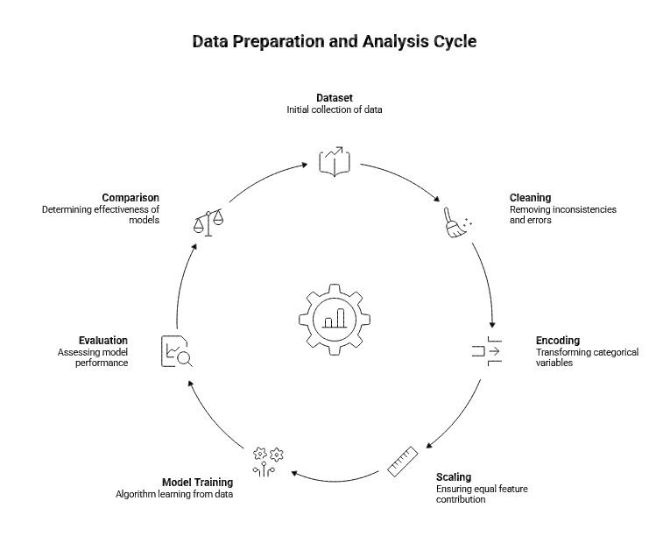

This structured methodology ensures that the system processes data efficiently and produces accurate and meaningful results. The integration of multiple machine learning techniques enhances the overall performance and reliability of the system.
DATASET DESCRIPTION & PREPARATION

Dataset Description
The dataset used in the Student Performance Analyzer project was collected using a combination of primary and automated data generation methods to ensure diversity, realism, and sufficient volume.
Data Collection Sources:
- Google Form Data Collection
  - A structured Google Form was created to collect real student responses.
  - It included questions related to academic performance and behavioral patterns.
  - Responses were automatically stored in an Excel sheet.
- Google Form Link - https://docs.google.com/forms/d/e/1FAIpQLScs-jqv6DpcquDI1Qnoxwxwbd7TinEp4HrSpkd1LrzTKfm8rg/viewform

- AI-Generated Realistic Data using Selenium
  - To increase dataset size and variability, automated scripts were developed using Selenium.
  - The script simulated realistic student responses and filled the Google Form multiple times.
  - This ensured:
    - Balanced data distribution
    - Reduced bias
    - Better model training

- Manually Added Data (Pasted Text Data)
  - Additional entries were included manually using structured text inputs.
  - This ensured coverage of edge cases and rare scenarios.

Dataset Features
Each record in the dataset represents an individual student and includes the following attributes:
- Current CGPA
- Expected Final Grade (Target Variable)
- Placement Readiness (Yes/No)
- Exam Preparation Style
- Assessment Completion Behavior
- Timestamp (data entry record)
The target variable is Expected Final Grade, which is used for prediction.

Dataset Nature
- Type: Structured dataset
- Format: Excel (.xlsx)
- Data Types:
  - Numerical: CGPA
  - Categorical: Placement readiness, preparation style
  - Target Variable: Converted into numerical form for modeling

Data Preparation Overview
Initial preprocessing was performed to prepare the dataset for machine learning models. This included cleaning, handling missing values, and converting categorical data into numerical format to ensure compatibility with algorithms and improve model performance.

Data Understanding

Initial analysis was performed using:
- head() → preview dataset
- info() → data types & null values
- describe() → statistical summary
- isnull().sum() → missing values

This helped in understanding dataset structure and quality.

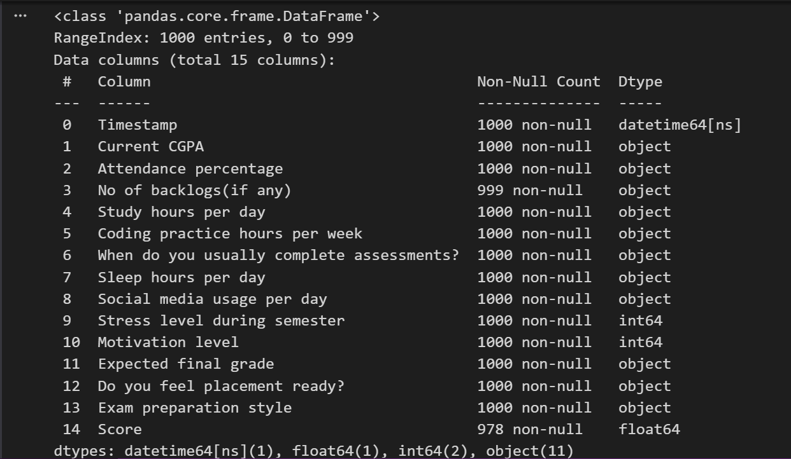

Data Preparation Steps

Data Understanding
Initial analysis of the dataset was performed to understand its structure, data types, and quality. Basic exploratory functions were used to examine the dataset, identify missing values, and obtain statistical summaries. This step helped in gaining insights into the distribution of data and detecting inconsistencies that required preprocessing.

Data Preparation Steps
- Data Cleaning
Irrelevant columns such as Timestamp were removed, and column names were standardized to ensure consistency and ease of processing.
- Handling Missing Values
Missing values were identified and handled using appropriate techniques such as mean and mode imputation to maintain dataset integrity.
- Data Type Conversion
The Current CGPA feature was converted into numeric format to ensure compatibility with machine learning models.
- Target Variable Transformation
The target variable Expected Final Grade, originally in categorical range format (e.g., “9+”, “7–8.5”), was converted into numerical values for regression modeling.
- Encoding Categorical Variables
- Binary Encoding: Placement Readiness (Yes = 1, No = 0)
- One-Hot Encoding: Exam Preparation Style
- Feature Selection
Important features were identified using correlation analysis and feature importance techniques (Random Forest), ensuring that only relevant variables were used for model training.

- Data Splitting
The dataset was divided into training and testing sets:
- Training Set: 80%
- Testing Set: 20%
This ensures that the model is evaluated on unseen data, improving its generalization capability.
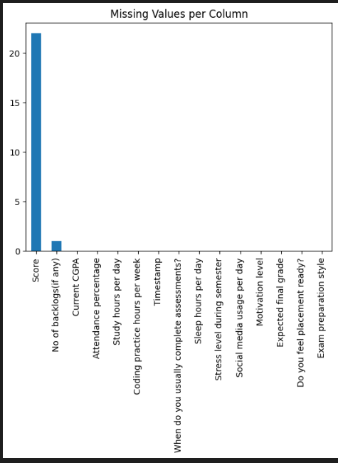

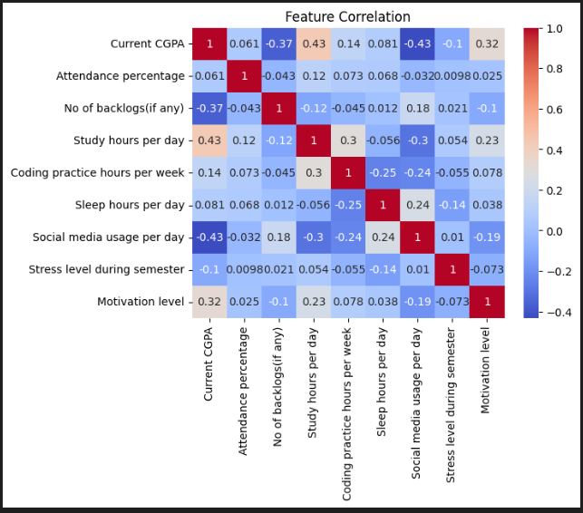

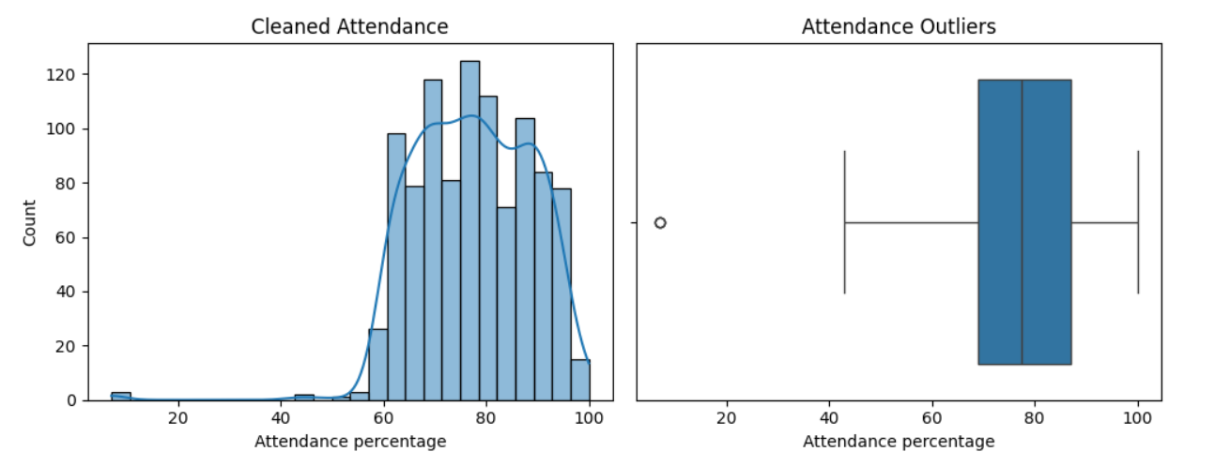

Exploratory Data Analysis (EDA)

Exploratory Data Analysis (EDA) was performed to gain insights into the dataset and understand the relationships between different features. Visualization techniques were used to identify patterns, trends, and correlations that influence student performance.
Visualizations Used:
- Correlation Heatmap
Used to analyze relationships between numerical features and identify strong correlations with the target variable.
- Bar Graphs
Used to examine the distribution of categorical variables such as placement readiness and preparation style.
- Feature Importance Plot
Generated using the Random Forest model to identify the most significant features affecting student performance.

Key Insights from EDA:
- Current CGPA has the strongest influence on the expected final grade
- Placement readiness shows a positive correlation with academic performance
- Preparation style impacts student outcomes and performance trends
Final Dataset Readiness
After preprocessing and analysis, the dataset became clean, consistent, and structured. All features were converted into machine-readable format, making the dataset suitable for regression-based machine learning models.

Importance of Dataset
The dataset serves as the foundation of the project, and its quality directly affects the accuracy and reliability of the machine learning models. Proper preprocessing and analysis ensure meaningful insights and improved prediction performance.

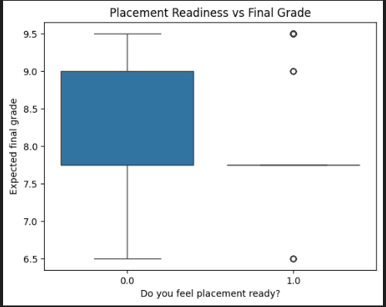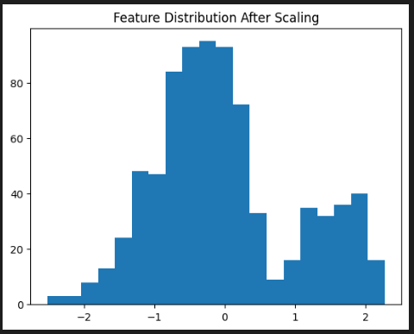
Advantages of the Project
The proposed system offers several significant advantages in the field of educational analytics:
- Early Identification of Student Performance
The system helps identify students who may be at risk of poor academic performance at an early stage, enabling timely intervention and corrective measures.
- Data-Driven Decision Making
The project replaces traditional intuition-based evaluation with data-driven insights, resulting in more accurate and objective analysis of student performance.
- Use of Multiple Machine Learning Models
The implementation of multiple supervised learning models such as Linear Regression, Decision Tree, KNN, and Random Forest enhances prediction accuracy and allows comparative analysis of model performance.
- Improved Understanding of Influencing Factors
Using feature importance analysis and correlation heatmaps, the project identifies key factors such as CGPA, preparation style, and placement readiness that significantly impact student performance.
- Scalable and Extendable System
The system can be extended to larger datasets, additional features, and real-time data integration, making it suitable for real-world applications.
- Automation and Efficiency
The use of tools such as Google Forms for data collection and Selenium for automated data generation reduces manual effort and improves efficiency.
- Visualization-Based Insights
Graphs such as heatmaps, bar charts, and feature importance plots help present results in an understandable manner for both technical and non-technical users.

Limitations of the Project
Despite its advantages, the project has certain limitations:
- Limited Real-World Data
A portion of the dataset is AI-generated and manually added, which may not fully represent real-world student behavior.
- Dependence on Selected Features
The model's performance depends on the selected features. Important factors such as mental health, personal conditions, and teaching quality are not included.
- Model Limitations
- Linear Regression assumes linear relationships, which may not always exist
- Decision Tree may suffer from overfitting
- KNN performance depends on the choice of k and distance metric
- Random Forest, although robust, increases computational complexity
- Data Imbalance
If certain categories dominate the dataset, the model may become biased toward those classes.
- Lack of Real-Time Implementation
The current system operates on static data and does not support live data input or real-time prediction.

RESULTS & DISCUSSION
In this section, multiple machine learning models were implemented and evaluated to predict student performance. The models include Linear Regression, Polynomial Regression, K-Nearest Neighbors (KNN), Decision Tree, Random Forest, and Tuned Random Forest. Each model was analyzed using performance metrics such as Mean Squared Error (MSE), Root Mean Squared Error (RMSE), Mean Absolute Error (MAE), and R² Score.
Linear Regression Results
Linear Regression was used as a baseline model to predict the expected final grade. The model captured general trends in the data but showed limitations in handling complex and non-linear relationships. The R² score indicated moderate performance with noticeable prediction errors.

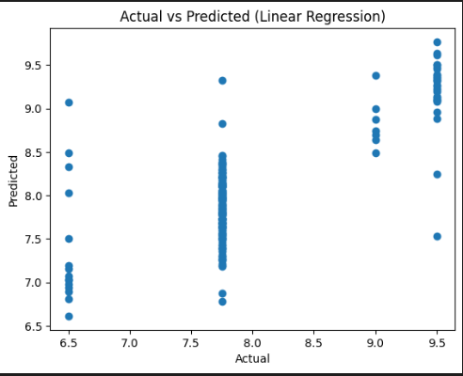

Polynomial Regression Results
Polynomial Regression was applied to capture non-linear relationships by introducing higher-order terms. However, the model did not significantly improve performance compared to Linear Regression and introduced additional complexity, indicating that the dataset does not strongly benefit from higher-order transformations.
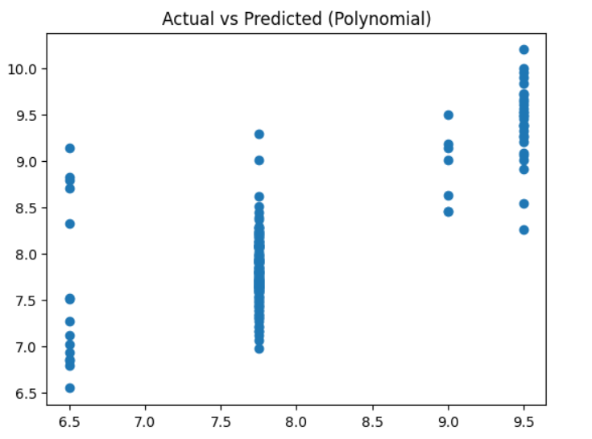
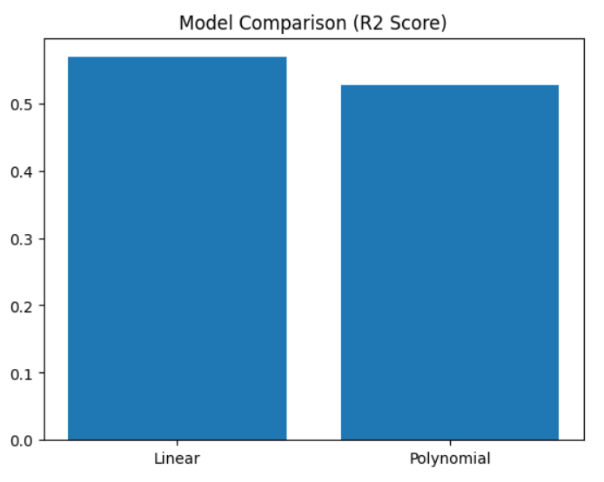
K-Nearest Neighbors (KNN) Results
The KNN model predicted student performance based on similarity between data points. After tuning the value of K, the model showed good performance with improved R² score. However, its performance was sensitive to the choice of K and feature scaling.

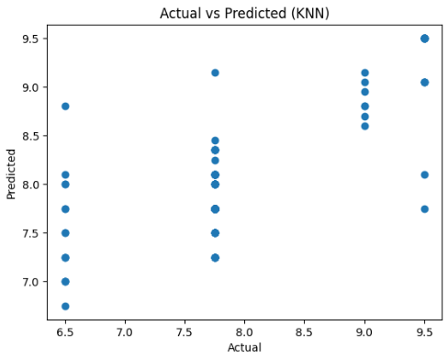
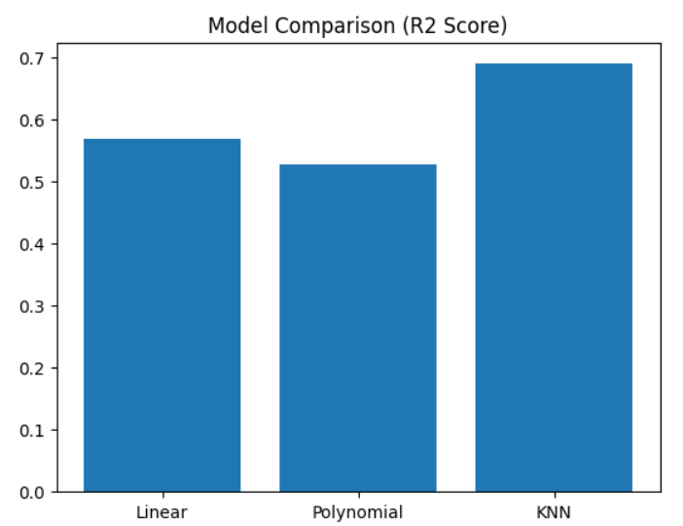

Decision Tree Results
The Decision Tree model effectively captured non-linear relationships by learning decision rules from the data. However, it showed signs of overfitting, resulting in lower generalization performance on unseen data.

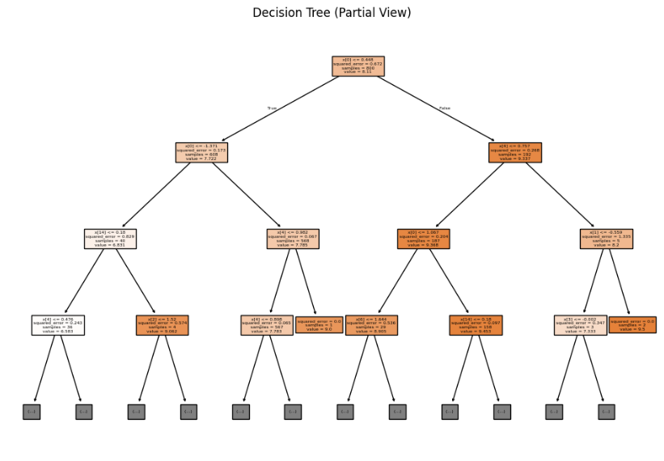

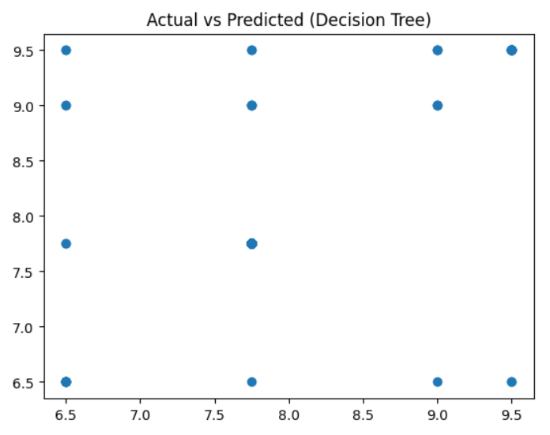

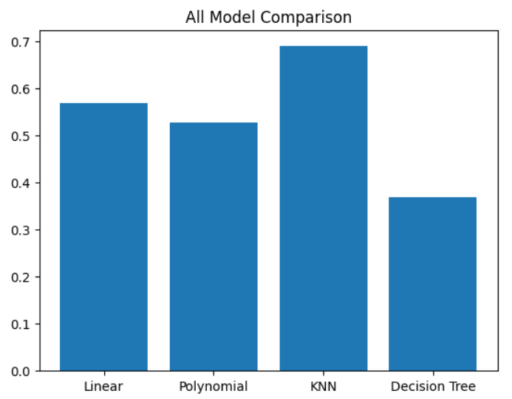

Random Forest Regressor Results
Random Forest, an ensemble learning technique, improved prediction accuracy by combining multiple decision trees. It reduced overfitting and provided more stable and accurate predictions compared to individual models.

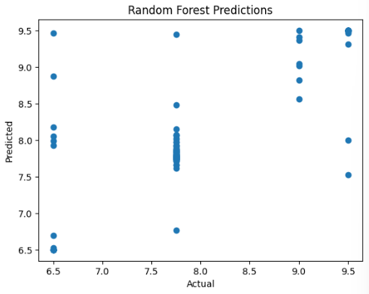
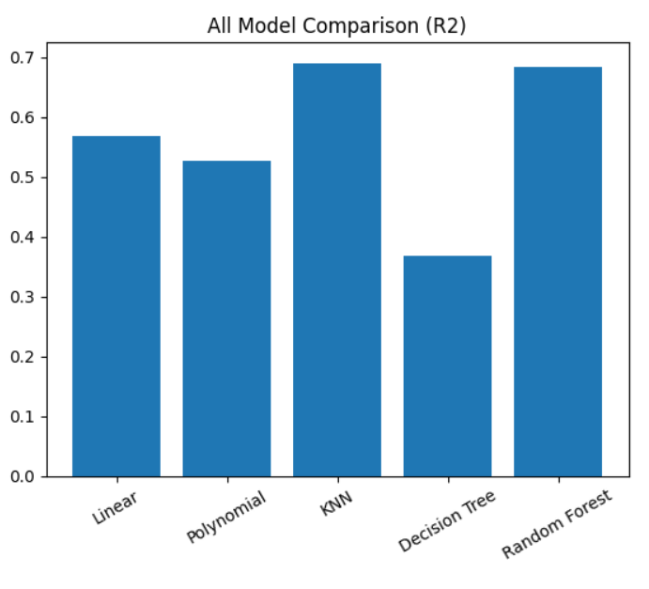

Tuned Random Forest Results
Hyperparameter tuning using RandomizedSearchCV further improved the performance of the Random Forest model. The tuned model achieved the highest R² score and lowest error values, making it the best-performing model.

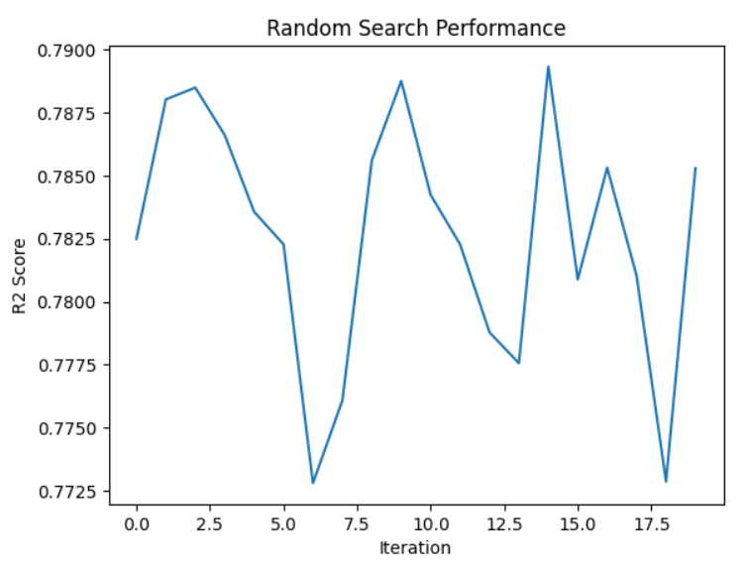
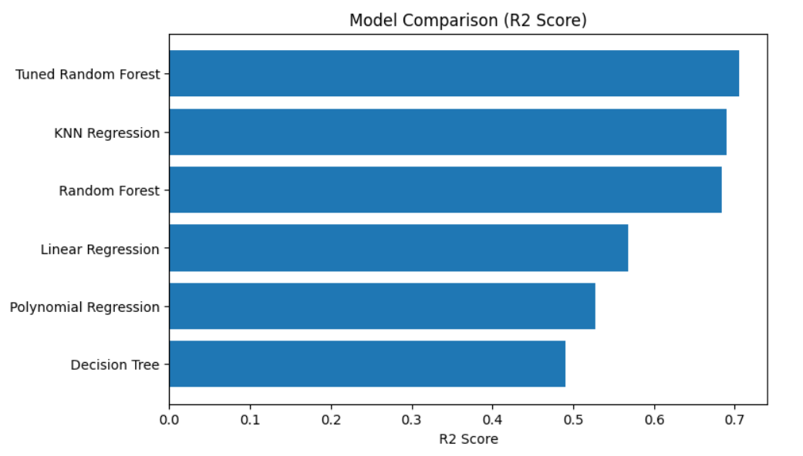

Model Comparison
A comparative analysis of all models was performed using evaluation metrics:
Model | Performance Level | Key Characteristics
Linear Regression | Moderate | Simple, assumes linear relationship
Polynomial Regression | Moderate | Adds complexity, limited improvement
KNN | High | Sensitive to K value and scaling
Decision Tree | Moderate | Captures non-linearity but overfits
Random Forest | Very High | Reduces overfitting, stable
Tuned Random Forest | Excellent | Best accuracy and generalization
The comparison shows that ensemble-based models outperform individual models due to better handling of complex patterns and reduced variance.

Summary of Results
The results demonstrate that different models perform differently based on their underlying approach. Linear and Polynomial models provide baseline performance, while KNN and Decision Tree capture non-linear relationships. Random Forest significantly improves prediction accuracy, and hyperparameter tuning further enhances its performance.
The Tuned Random Forest model is selected as the final model due to:
- Highest R² Score
- Lowest error values (MSE, RMSE, MAE)
- Better generalization capability

Discussion
The results highlight the importance of model selection, preprocessing, and hyperparameter tuning in achieving optimal performance. Ensemble methods proved to be more reliable for this dataset, while simpler models were limited in capturing complex relationships. Proper data preprocessing and feature engineering also played a crucial role in improving model accuracy.

CONCLUSION & FUTURE SCOPE

Conclusion
The project successfully demonstrates the application of machine learning techniques for predicting student academic performance. Multiple supervised learning models, including Linear Regression, Polynomial Regression, K-Nearest Neighbors (KNN), Decision Tree, and Random Forest, were implemented and evaluated.
Among all models, the Random Forest Regressor, particularly after hyperparameter tuning, achieved the best performance due to its ability to handle non-linear relationships, reduce overfitting, and provide stable and accurate predictions.
The results indicate that student performance can be effectively predicted using a combination of academic and behavioral features such as CGPA, preparation style, and placement readiness. The project also highlights the importance of data preprocessing, feature engineering, and model comparison in building an efficient predictive system.
Overall, this work demonstrates how machine learning can support data-driven decision-making in education and assist educators in identifying students at risk of poor performance.

Future Scope
Although the project achieves its objectives, there are several opportunities for further improvement:
- Use of Larger and Real-World Datasets
Incorporating real-world institutional data can improve model accuracy and practical applicability.
- Application of Advanced Machine Learning Models
Advanced algorithms such as XGBoost, Gradient Boosting, and Deep Learning models can be implemented to enhance prediction performance.
- Development of a Web-Based Application
The system can be deployed as an interactive web application where users can input data and receive real-time predictions.
- Integration of Real-Time Data
The model can be extended to handle live data inputs for continuous monitoring of student performance.

Inclusion of Additional Features
Additional factors such as psychological aspects, learning environment, and teaching quality can be incorporated for more comprehensive analysis.
- Interactive Visualization Dashboard
Developing a dynamic dashboard with visual analytics can improve usability for educators and institutions.

REFERENCES

[1] Scikit-learn: Machine Learning in Python, Journal of Machine Learning Research, 2011.

[2] Kaggle, Dataset Source. Available at: https://www.kaggle.com/

[3] Pandas Documentation. Available at: https://pandas.pydata.org/

[4] NumPy Documentation. Available at: https://numpy.org/

[5] Matplotlib Documentation. Available at: https://matplotlib.org/

[6] Scikit-learn Documentation. Available at: https://scikit-learn.org/

APPENDIX (PROJECT CODE)
This section contains the implementation details and code snippets used in the project for data preprocessing, model training, evaluation, and visualization.

1. Importing Libraries
import pandas as pd
import numpy as np
import matplotlib.pyplot as plt
import seaborn as sns

2. Loading Dataset
df = pd.read_excel("dataset.xlsx")
df.columns = df.columns.str.strip()

print(df.head())
print(df.info())
print(df.describe())
print(df.isnull().sum())

3. Handling Missing Values
df['No of backlogs(if any)'] = df['No of backlogs(if any)'].fillna(
df['No of backlogs(if any)'].mode()[0]
)

df['Current CGPA'] = pd.to_numeric(df['Current CGPA'], errors='coerce')
df['Current CGPA'] = df['Current CGPA'].fillna(df['Current CGPA'].mean())

4. Cleaning Attendance Data
import re

def clean_attendance(x):
x = str(x)
numbers = re.findall(r'\d+\.?\d*', x)

if len(numbers) == 0:
return None

value = float(numbers[0])

if value < 1:
value = value * 100

return value

df['Attendance percentage'] = df['Attendance percentage'].apply(clean_attendance)
df['Attendance percentage'] = df['Attendance percentage'].fillna(
df['Attendance percentage'].mean()
)

5. Converting Range-Based Values
def convert_range(x):
x = str(x)
numbers = re.findall(r'\d+\.?\d*', x)

if not numbers:
return None

if len(numbers) >= 2:
return (float(numbers[0]) + float(numbers[1])) / 2
else:
return float(numbers[0])

df['Study hours per day'] = df['Study hours per day'].apply(convert_range)
df['Coding practice hours per week'] = df['Coding practice hours per week'].apply(convert_range)
df['Sleep hours per day'] = df['Sleep hours per day'].apply(convert_range)
df['Social media usage per day'] = df['Social media usage per day'].apply(convert_range)

6. Target Variable Transformation
def convert_grade(x):
x = str(x).strip()

if '9+' in x:
return 9.5
elif '8.5+' in x:
return 9.0
elif '7-8.5' in x:
return (7 + 8.5) / 2
elif 'Below 7' in x:
return 6.5
else:
return None

df['Expected final grade'] = df['Expected final grade'].apply(convert_grade)

7. Encoding Categorical Variables
df['Do you feel placement ready?'] = (
df['Do you feel placement ready?']
.astype(str)
.str.strip()
.str.lower()
.map({'yes': 1, 'no': 0})
)

df = pd.get_dummies(
df,
columns=[
'When do you usually complete assessments?',
'Exam preparation style'
],
drop_first=True
)

8. Train-Test Split
from sklearn.model_selection import train_test_split

X = df.drop(columns=['Expected final grade'])
y = df['Expected final grade']

X_train, X_test, y_train, y_test = train_test_split(
X, y, test_size=0.2, random_state=42
)

9. Feature Scaling
from sklearn.preprocessing import StandardScaler

X_train = X_train.drop(columns=['Timestamp'], errors='ignore')
X_test = X_test.drop(columns=['Timestamp'], errors='ignore')

X_train = X_train.apply(pd.to_numeric, errors='coerce')
X_test = X_test.apply(pd.to_numeric, errors='coerce')

train_means = X_train.mean()
X_train = X_train.fillna(train_means)
X_test = X_test.fillna(train_means)

scaler = StandardScaler()
X_train = scaler.fit_transform(X_train)
X_test = scaler.transform(X_test)

10. Linear Regression
from sklearn.linear_model import LinearRegression

lr = LinearRegression()
lr.fit(X_train, y_train)

y_pred_lr = lr.predict(X_test)

11. Polynomial Regression
from sklearn.preprocessing import PolynomialFeatures

poly = PolynomialFeatures(degree=2)

X_train_poly = poly.fit_transform(X_train)
X_test_poly = poly.transform(X_test)

poly_model = LinearRegression()
poly_model.fit(X_train_poly, y_train)

y_pred_poly = poly_model.predict(X_test_poly)

12. KNN Regression
from sklearn.neighbors import KNeighborsRegressor

knn = KNeighborsRegressor(n_neighbors=5)
knn.fit(X_train, y_train)

y_pred_knn = knn.predict(X_test)

13. KNN Hyperparameter Tuning
from sklearn.metrics import r2_score

r2_scores = []
k_values = range(1, 21)

for k in k_values:
model = KNeighborsRegressor(n_neighbors=k)
model.fit(X_train, y_train)
y_pred = model.predict(X_test)
r2_scores.append(r2_score(y_test, y_pred))

best_k = k_values[np.argmax(r2_scores)]
print("Best k:", best_k)

14. Cross Validation
from sklearn.model_selection import cross_val_score

knn_best = KNeighborsRegressor(n_neighbors=7)

cv_scores = cross_val_score(
knn_best, X_train, y_train, cv=5, scoring='r2'
)

print("Cross Validation Scores:", cv_scores)
print("Average R2:", cv_scores.mean())
print("Standard Deviation:", cv_scores.std())

15. Decision Tree Regression
from sklearn.tree import DecisionTreeRegressor

dt = DecisionTreeRegressor(random_state=42)
dt.fit(X_train, y_train)

y_pred_dt = dt.predict(X_test)

16. Random Forest Regression
from sklearn.ensemble import RandomForestRegressor

rf = RandomForestRegressor(n_estimators=100, random_state=42)
rf.fit(X_train, y_train)

y_pred_rf = rf.predict(X_test)

17. PCA
from sklearn.decomposition import PCA

pca = PCA(n_components=2)
X_pca = pca.fit_transform(X_train)

plt.plot(pca.explained_variance_ratio_, marker='o')
plt.title("Explained Variance by Components")
plt.xlabel("Principal Components")
plt.ylabel("Variance Ratio")
plt.show()

plt.figure(figsize=(8,6))
scatter = plt.scatter(X_pca[:,0], X_pca[:,1], c=y_train)
plt.colorbar(scatter, label='Expected Final Grade')
plt.xlabel("Principal Component 1")
plt.ylabel("Principal Component 2")
plt.title("PCA Visualization")
plt.show()

18. Random Forest Hyperparameter Tuning
from sklearn.model_selection import RandomizedSearchCV

param_grid = {
'n_estimators': [100, 200, 300, 400],
'max_depth': [None, 5, 10, 15, 20],
'min_samples_split': [2, 5, 10],
'min_samples_leaf': [1, 2, 4]
}

rf = RandomForestRegressor(random_state=42)

rf_random = RandomizedSearchCV(
estimator=rf,
param_distributions=param_grid,
n_iter=20,
cv=5,
scoring='r2',
random_state=42,
n_jobs=-1
)

rf_random.fit(X_train, y_train)

best_rf = rf_random.best_estimator_
y_pred_final = best_rf.predict(X_test)

print("Best Parameters:", rf_random.best_params_)

19. Model Evaluation Function
from sklearn.metrics import mean_squared_error, mean_absolute_error, r2_score

def regression_report(y_true, y_pred, model_name="Model", n_features=None):
mse = mean_squared_error(y_true, y_pred)
rmse = np.sqrt(mse)
mae = mean_absolute_error(y_true, y_pred)
r2 = r2_score(y_true, y_pred)

n = len(y_true)

if n_features is not None:
adj_r2 = 1 - (1 - r2) * (n - 1) / (n - n_features - 1)
else:
adj_r2 = None

return {
"Model": model_name,
"MSE": round(mse, 4),
"RMSE": round(rmse, 4),
"MAE": round(mae, 4),
"R2 Score": round(r2, 4),
"Adjusted R2": round(adj_r2, 4) if adj_r2 else None
}

20. Final Model Report
reports = []

reports.append(regression_report(y_test, y_pred_lr, "Linear Regression", X_test.shape[1]))
reports.append(regression_report(y_test, y_pred_poly, "Polynomial Regression", X_test.shape[1]))
reports.append(regression_report(y_test, y_pred_knn, "KNN Regression", X_test.shape[1]))
reports.append(regression_report(y_test, y_pred_dt, "Decision Tree", X_test.shape[1]))
reports.append(regression_report(y_test, y_pred_rf, "Random Forest", X_test.shape[1]))
reports.append(regression_report(y_test, y_pred_final, "Tuned Random Forest", X_test.shape[1]))

report_df = pd.DataFrame(reports)
report_df = report_df.sort_values(by="R2 Score", ascending=False)

print("FINAL MODEL REPORT")
print(report_df)

21. Feature Importance
importances = rf.feature_importances_

features = df.drop(
columns=['Expected final grade', 'Timestamp'],
errors='ignore'
).columns

feature_df = pd.DataFrame({
'Feature': features,
'Importance': importances
})

feature_df = feature_df.sort_values(by='Importance', ascending=False)

top_features = feature_df.head(10)

plt.figure(figsize=(8,5))
plt.barh(top_features['Feature'], top_features['Importance'])
plt.gca().invert_yaxis()
plt.title("Top 10 Important Features")
plt.show()

22. Residual Analysis
def residual_analysis(y_true, y_pred, model_name):
residuals = y_true - y_pred

plt.figure(figsize=(6,4))
plt.hist(residuals, bins=20)
plt.title(f"{model_name} Residual Distribution")
plt.show()

residual_analysis(y_test, y_pred_rf, "Random Forest")

Note:
The complete implementation code is provided in the project files and can be referred to for detailed understanding and reproducibility.

